**Specification Document**

Team Name- Parallax Date- 19 Sep. 2023

**Introduction**

**Project purpose:** The purpose of this document is to outline the requirements and specifications for the development of a web or mobile application that assists users in planning their daily activities, setting reminders, prioritizing tasks, and tracking their progress. The Day Planner application aims to streamline users' daily routines and enhance their productivity.

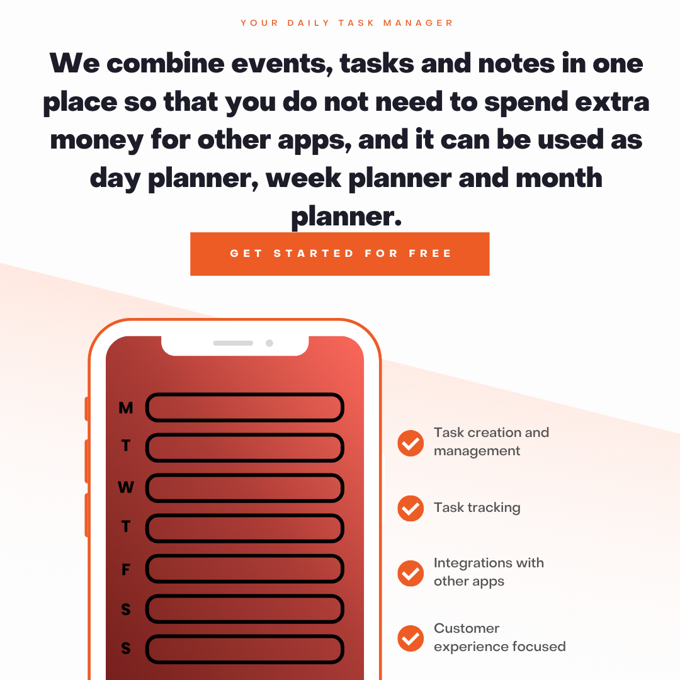

**Project Scope:**

* Registration and login for single user and team collaboration.
* Task Adding- User can add Personal, work miscellaneous tasks in list.
* Adding notes and links to tasks for revision.
* Adding progress bar to track progress.
* Interface for Tasks- All task, weekly task and daily task.
* Calendar integration for meeting and day planning.
* Adding weather forecasts for planning outdoor activities.
* Prioritizing tasks.
* Searching and filtering out tasks.
* Adding Recurring tasks like bill payment.
* Reminder through notification and emails.
* Adding Team space for collaboration.
* Tracking for daily expanses.
* Integrating Gmail.
* Colour themes and labels.

User Actions:

